Original

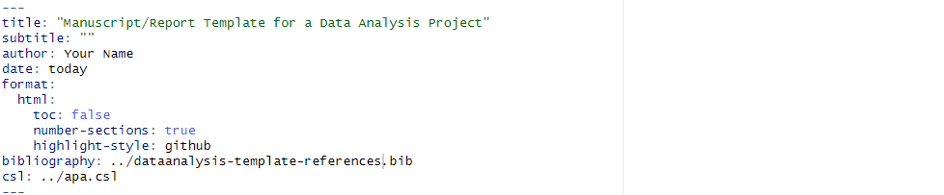

Mine

Original layout for

title: "Honey Bee Colonies Impacted by Varroa, American Foulbrood and Global Warming"

subtitle: ""

author: Edward Cruz, Jr., Leonel G. Salazar, Amelia Tristan, Mojisola Popoola

date: today

format:

html:

toc: false

number-sections: true

highlight-style: github

bibliography: ../dataanalysis-template-references.bib

csl: ../apa.csl

editor:

markdown:

wrap: 72

@article{hivecollapse,

author = {Brian Dennis and William P. Kemp},

title = {How Hives Collapse: Allee Effects, Ecological Resilience, and the Honey Bee},

journal = {PLOS ONE},

year = {2016},

volume = {11},

number = {2},

pages = {e0150055},

doi = {10.1371/journal.pone.0150055},

url = {https://doi.org/10.1371/journal.pone.0150055}

}

@misc{us,

author = {sdns6mchl4},

title = {Varroa mite spread in the United States},

year = {2016},

month = {February 24},

url = {https://www.beesource.com/threads/varroa-mite-spread-in-the-united-states.365462/},

note = {Beesource Beekeeping Forums}

}

@misc{usda_honey_bees,

author = {{USDA Economics, Statistics and Market Information System}},

title = {Index Catalog},

year = {n.d.-a},

url = {https://usda.library.cornell.edu/catalog?f%5Bkeywords_sim%5D%5B%5D=honey+bees&locale=en},

note = {Accessed: 2024-07-31}

}

@misc{usda_nass,

author = {{USDA - National Agricultural Statistics Service}},

title = {Surveys - honey bee surveys and reports},

year = {n.d.},

url = {https://www.nass.usda.gov/Surveys/Guide_to_NASS_Surveys/Bee_and_Honey/},

note = {Accessed: 2024-07-31}

}

Dennis and Kemp's study on honey bee hive collapse [@dennis2016] provides important insights into Allee effects and ecological resilience.